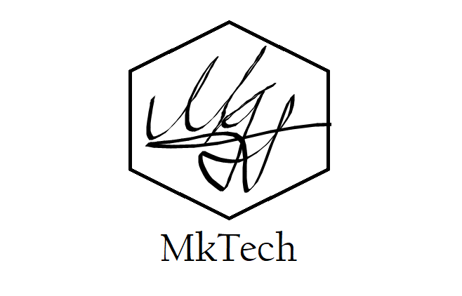

Project plan

7G wines

by mIHAIL kenarov

Table of content

Version control 2

Our client 3

Our team 3

Current situation 4

Problem description 5

Project goal 6

Deliverables 7

Non-deliverables 8

Constraints 9

Phasing 10

# Version control

|  |  |  |
| --- | --- | --- |
| Version | Date | Changes |
| 0.1 | 20 february 2023 | Initial document version |

# Our client

Our client is 7G Wines, which are a company, that specializes in selling wines and additional treats with them. They run two stores that are free to visit in Veliko Tarnovo and want to open an in-site one there as well.

Their representative is Teodora Nikolova

Contact to the representative via email: <NaTeodoraPoshtata@gmail.com>

# Our team

Our company is “MkTech”. We are a recently created company, that was founded by young software engineers, who are ready to face new challenges and provide their services. The project leader who you can turn to is:

* Mihail Kenarov (mail: [m.kenarov@student.fontys.nl](mailto:m.kenarov@student.fontys.nl))

# Current situation

At the moment, 7G wines have no software system that handles their business, which is the reason why they hired us, a young and creative software team, capable of creating one for them. We are going to build a software system that will help them develop their business.

# Problem description

7G wines does not have an easy or straightforward way of managing their stock. Currently, they are using excel sheets to keep track of the stock, but this method has been described as “inefficient” by them.

Problems mentioned by the client:

- The highest priority problem is that there is no way to manage the stock.

- The business does not have a database

# Project goal

The goal of this project is to reach broader audience, while also being able to receive feedback on the products that are offered

# Deliverables

* Web application that allows its users to be able to communicate better with the company, while also being able to purchase products.
* Desktop application that helps the company track their stock

# Non-deliverables

We will not deliver post-deployment service. Once we deploy the product, we do not stay accountable for maintaining the product.

# Constraints

Our only limitations are:

* Deliver complete solution until the 31st of March.
* We are limited to use .NET and ASP.NET
  + Windows Forms for the desktop application
  + Razor Pages for the web application

# Phasing

Week 1:

* Create a name and logo for your company.
* Interview client
* Create project plan.

Week 2:

* Create URS

Week 3:

* Improve URS based on feedback.
* Improve project plan based on feedback.
* Submit intermediate version.

Week 4:

* Implement software solution

Week 5:

* Implement software solution
* Create test plan (workshop)
* Send test plan and binaries to peers
* Review peers and create test report (fill received test plan in).

Week 6:

* Tag software as deliverable in GIT repository
* Present final version to client and peers
* Submit version that is the product of Waterfall phase